Here I change the bash using this commn “chsh -s /bin/sh” then I reboot the ubuntu then when I checked y writing ehco “$SHEL” I found its chnged

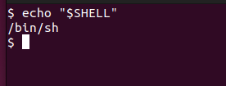

I did the same thing in cetos

